Apply filters to SQL queries
Project description
I have been informed that a potential security issue occurred after business hours and needs to be investigated. I’ll use and apply the correct SQL queries to not only investigate the issue but also determine its cause.
Retrieve after hours failed login attempts
The security team investigated failed login attempts made after business hours. Using the following SQL query: (SELECT *, SELECT * FROM log_in_attempts WHERE login_time > '18:00' AND success = 0;

I discovered 19 failed login attempts that were made after 18:00 (6:00 PM).
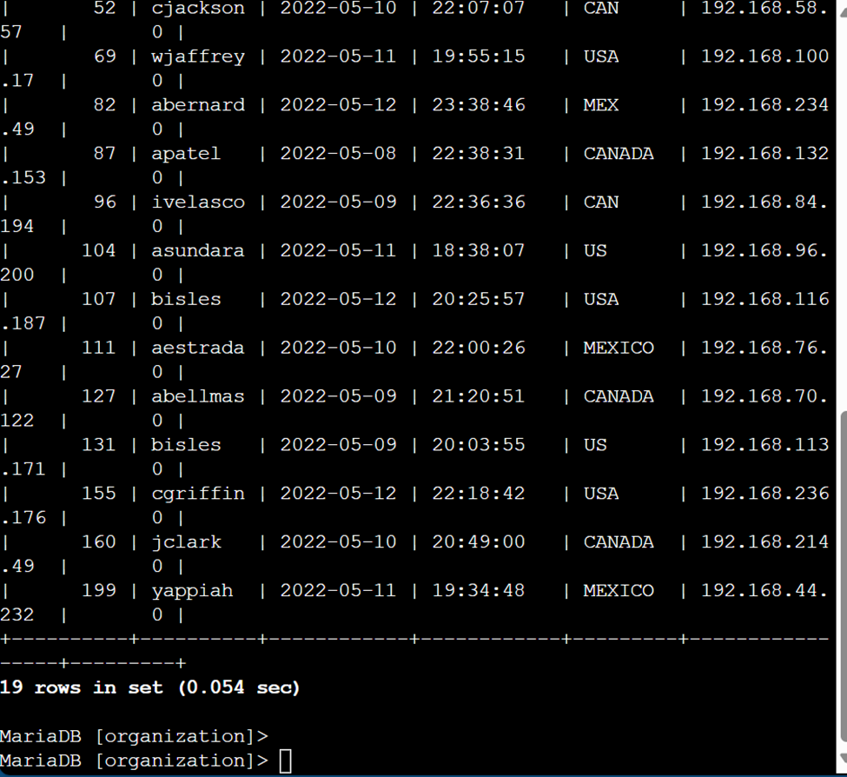

Retrieve login attempts on specific dates
Using the query (SELECT * , FROM log_in_attempts, WHERE login_date = '2022-05-09' OR login_date = '2022-05-08';) I retrieved login attempts on May 8 and May 9, when suspicious activity occurred. Over these two days, there were 75 total login attempts.

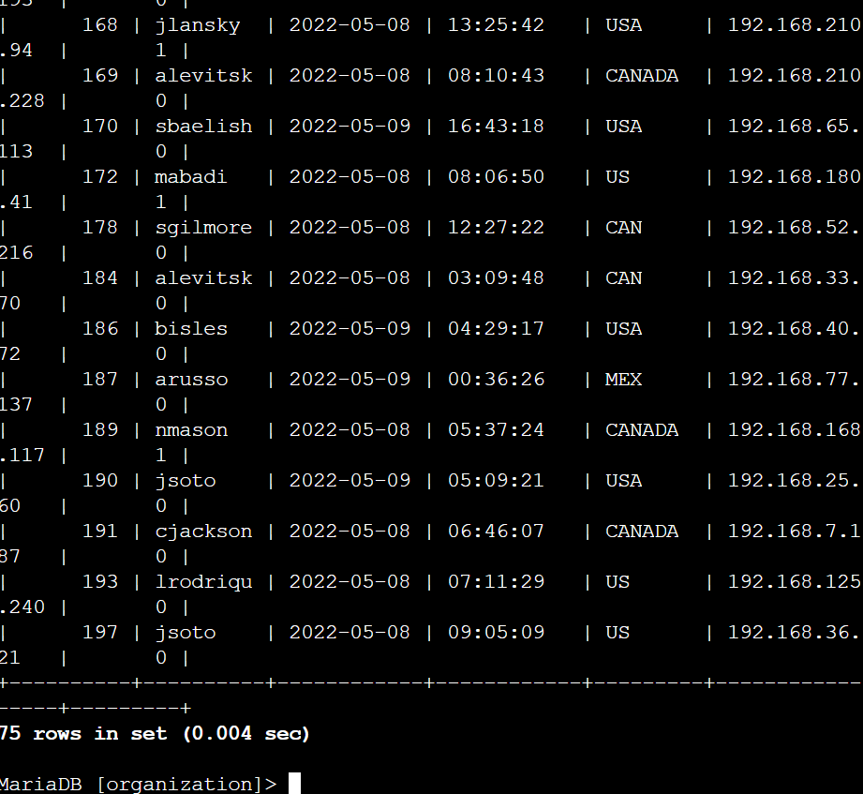

Retrieve login attempts outside of Mexico
Next, the security team investigated login attempts that occurred outside of Mexico. Using the query: SELECT * FROM log_in_attempts WHERE NOT LOWER(country) LIKE 'mex%';

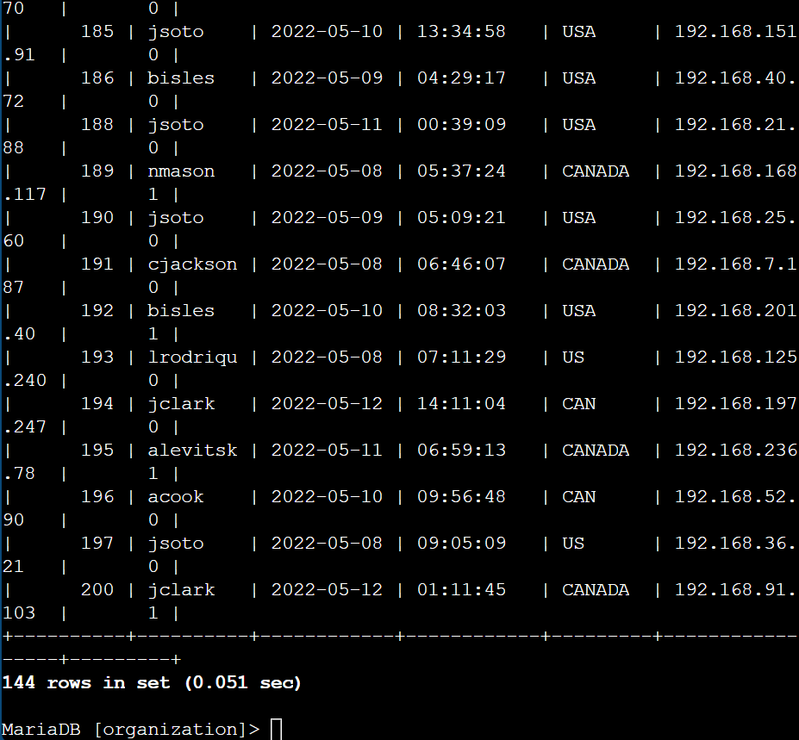
I determined that 144 login attempts were made outside the country.

Retrieve employees in Marketing
To analyze employee data, I first viewed the columns and values in the employees table using: (SELECT *, FROM employees;) 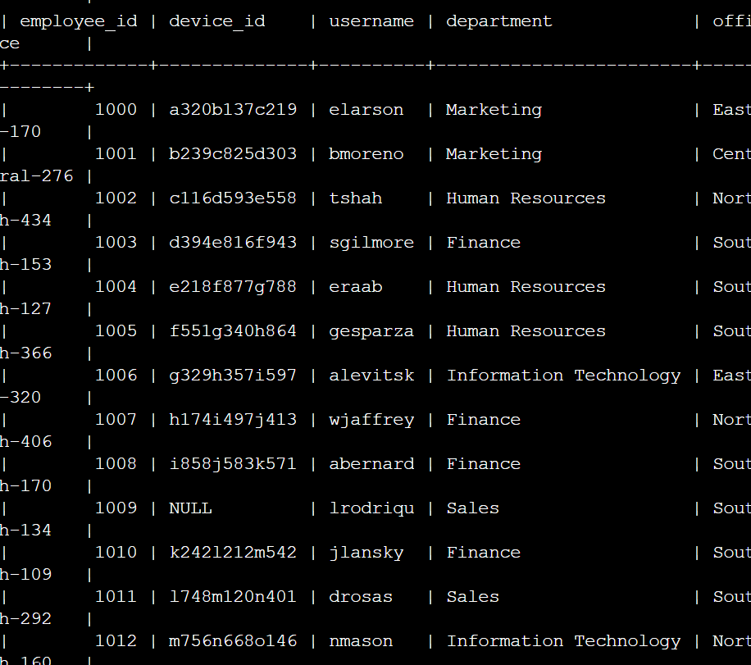
Then, I retrieved information about employees in the Marketing department located in all offices on the east side of the building using: (SELECT *, FROM employees, WHERE department = 'Marketing' AND office LIKE 'East%';) This identified an employee with the username ‘elarson.’ ‘elarson’. 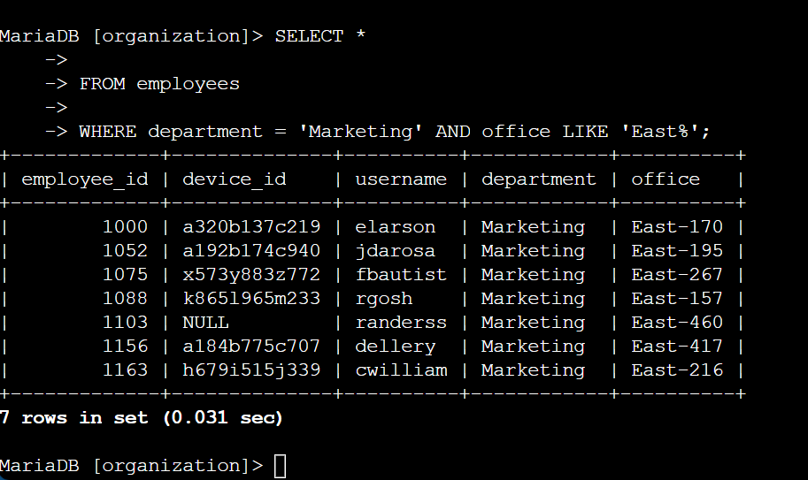

Retrieve employees in Finance or Sales
Next, the security team and I performed system updates for employees in the Finance and Sales departments. To locate their information, I used: (SELECT *, FROM employees, WHERE department = 'Finance' OR department = 'Sales';)
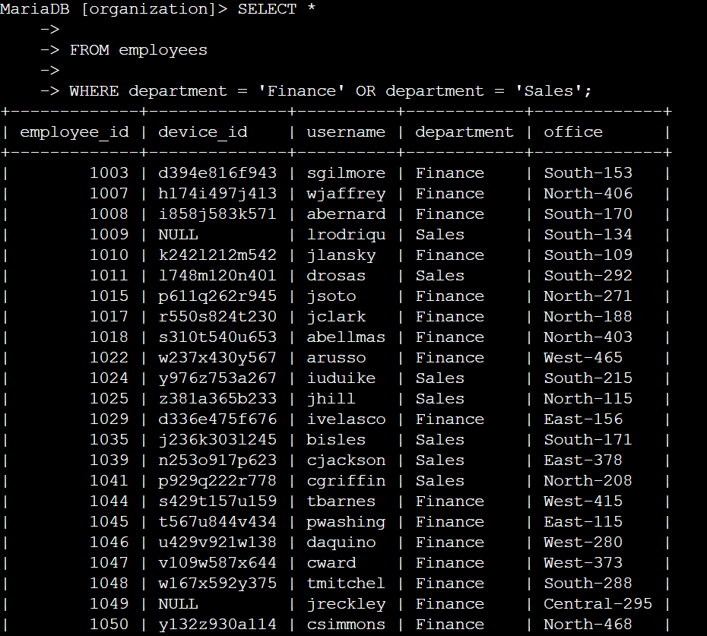

Retrieve all employees not in IT
Finally, the security team needed to update employees outside of the IT department. Since an update had already been made to IT employees, I used: SELECT * FROM employees WHERE NOT department = 'Information Technology';

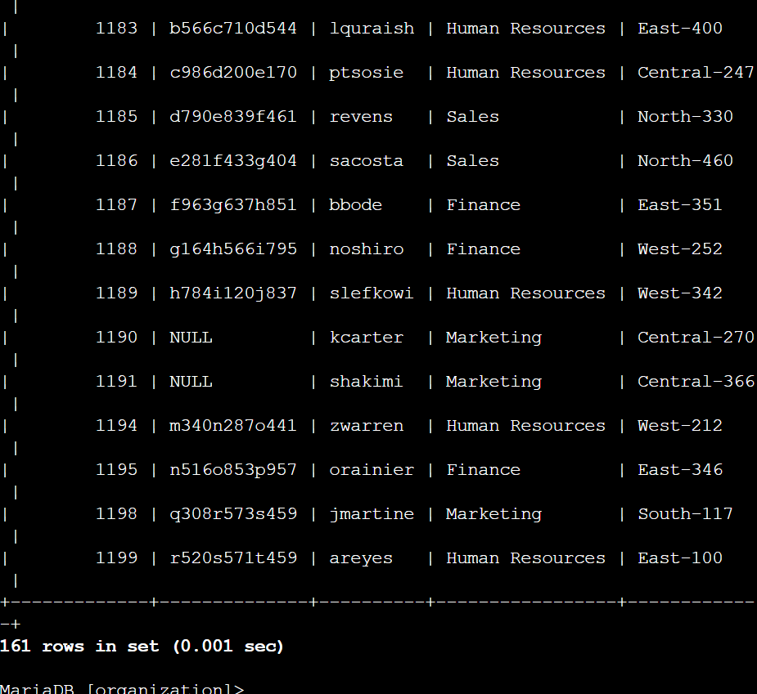

Summary
I investigated a potential security issue that occurred after business hours by using SQL queries to filter data. First, I checked for failed login attempts after 18:00 and found 19. Then, I retrieved login attempts on May 8 and May 9, totaling 75. After that, I identified 144 login attempts from outside Mexico to check for unauthorized access. For employees, I found Marketing staff on the east side, which led to an employee named ‘elarson.’ I also retrieved Finance and Sales employees for system updates. Lastly, I listed all employees not in IT to track previous updates. These queries helped me break down the issue and uncover key details for the investigation.

